Whether you’ve had a big accident or a minor bump, it’s important to tell AVIVA about it straight away. They can help get us back on the road quickly and protect us against insurance fraud. The first step is to let AVIVA know about the claim as soon as possible and all the details about any third party involved, especially their phone number. It’s always better to make a claim early, when it’s fresh in your mind. There’s more chance of getting photos, CCTV footage and accurate witness statements too. But even if you don’t plan to make a claim ― or if there was no damage ― let us know. That way AVIVA can get your side of the story if someone else makes a false claim.

MESSAGE TO OUR DRIVER:
In the event of an accident take the following actions:
If anyone is injured report to police and call an ambulance;
Do not admit liability;
Exchange details (use the ter off section of your bump card);
Obtain names and telephone numbers of other drivers;
If you have access to a camera and it is safe to use it please take photographs of the third-party vehicle damage.

POLICYHOLDER – CARMARTHENSHIRE COUNTY COUNCIL

Policy Number (25/26): 100797937CMI |  | Claim Reference (TBC by Risk):
Driver Name |  |  | Employee Number
Date of Incident |  |  | Time of the Incident
Location of the Incident
Own Registration Number
Incident Summary
(Further details may be recorded in the additional space provided under Section F.)
Confirm an area of damage to the Own Vehicle on the diagram below (the diagram is illustrative only and may not reflect the specific vehicle driven. Please use it to indicate the position of the damage as accurately as possible, regardless of vehicle type):
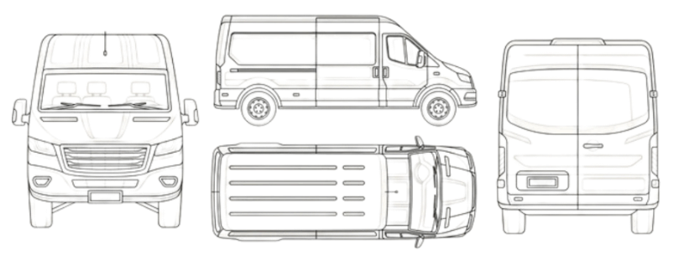
`

Do you accept that you were responsible for the accident? | YES / NO

3RD PARTY

3rd Party Name:

3rd Party Registration Number:

Number of passengers (incl. driver)
Any visible/apparent personal injury sustained?
Contact details:
- Phone/mobile number:
Confirm an area of damage to the Third-Party Vehicle on the diagram: (the diagram is illustrative only and may not reflect the specific vehicle driven. Please use it to indicate the position of the damage as accurately as possible, regardless of vehicle type):
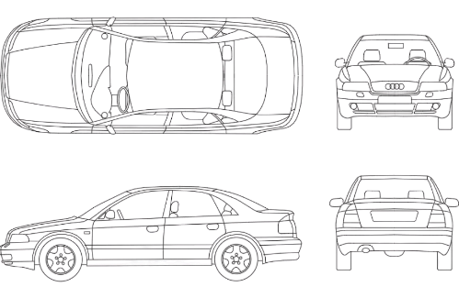

NOTIFICATION
You are required to give details of any accident, loss, or damage and all subsequent developments as soon as reasonably possible, even if you do not wish to claim under your policy.

THIRD PARTY CLAIMS
Any Third-Party communication or any legal document must be sent to us immediately and unanswered. You must not admit, deny, negotiate or promise to pay any claim without our written consent.

THEFT OF VEHICLE
Most stolen vehicles are eventually recovered and restored to their owners, and it is normal to wait a reasonable period of time before settlement of the claim is finalised. You should complete and return this form to us as soon after the theft as possible, together with the following documents if applicable:
a) Vehicle Registration Document,
b) Test Certificate,
c) Purchase Invoice,
d) Finance/Leasing Agreement,
e) Plating Certificate,
f) Servicing Documents,
g) Vehicle Keys (all sets).

Insurers pass information to the Claims and Underwriting Exchange Register, run by Insurance Database Services Ltd (IDS Ltd) and the Motor Insurance Anti-Fraud and Theft Register, run by the Association of British Insurers (ABI). The aim is to help us to check information provided and also to prevent fraudulent claims. Under the conditions of your policy, you must tell us about any incident (such as an accident or theft) which may or may not give rise to a claim. We will pass information relating to this incident to the registers.

NOTE: Please use separate sheet(s) of paper to respond to questions if there is insufficient space on the form.

PAGES 3-10 – FULL CLAIM DETAILS – COMPLETE WITHIN 7 DAYS

- PERSON DRIVING OR IN CHARGE OF THE INSURED VEHICLE
Residential Address:  Postcode: |  | Date of Birth:
Residential Address:  Postcode: |  | Occupation:  Department:
Telephone Number: |  | Relationship to the policyholder (e.g. employee)
Type of Driver’s Licence Held? |  | Details, including groups covered and current period of any other licences held (e.g. HGV 1/2/3, PCV)
Date UK driving test passed

Is the driver or person in charge of the vehicle the main user? YES / NO

If ‘No’, please give further details:

- Has the driver or person in charge of the vehicle had any other accident, loss or claim in connection with any motor vehicle during the past 5 years? YES / NO
- Has he/she been convicted of any offence (including fixed penalty notices) in connection with any motor vehicle during the last 5 years? YES / NO
- Has the driver’s licence been suspended or the driver disqualified at any time? YES / NO
- Has the driver had any condition which could affect fitness as a driver e.g. diabetes, epilepsy heart condition, physical or mental illness or disability? YES / NO

If you have answered ‘Yes’ to any of the above, please give details below:

- INSURED VEHICLE

Registration Number | Make/Model |  | Year of Manufacture |  | CC
Name and address of owner:  Carmarthenshire County Council, County Hall Castle Hill, Carmarthen  Postcode:SA31 1JP |  |  |  | Name and address of registered keeper:  Carmarthenshire County Council, County Hall Castle Hill, Carmarthen  Postcode:SA31 1JP
If the vehicle is the subject of any hire, lease or finance agreement (including hire purchase), please give details:

- USE OF THE INSURED VEHICLE

State the exact purpose for which the vehicle was being used (“Business” or “Private” is not sufficient)

 |  | If ‘No’, give details
  Was the vehicle being used with the
  Policyholder's knowledge and consent? YES / NO
No. of passengers being carried (excluding driver) |  | Relationship of passengers to driver (e.g. employee)

Were CCTV / telematics / tachograph being used in this vehicle? YES / NO

- ACCIDENT

Were police involved? YES / NO

If ‘Yes’, give police officer’s name, number and station

Weather conditions/condition of road surface? |  | What speed limit was in force?
Further details may be recorded here:
Give description of accident (include details of statement of blame or admission of liability and by whom). Sketch layout of road(s) and show approximate measurements; names of roads; position of vehicles and persons involved; the direction in which vehicles travelling; the registration marks of all vehicles (where known); any road markings, road signs, traffic lights, streetlights, pedestrian crossing and any other relevant information. Use separate sheet if necessary.

Did this collision involve a reversing manoeuvre? | YES / NO
Was a banksman available to support the driver when reversing? | YES / NO
Was a banksman used to support the driver when reversing? | YES / NO

Is the insured vehicle still in use? YES / NO

If the insured vehicle is not in use, where is it now?

Who should we contact to make an appointment to inspect the vehicle?

- Independent Witness details:

Name | Address | Where was the witness? | Contact Details

Third Parties involved:

 | Third Party Vehicle 1  Registration No:  Make and Model: | Third Party Vehicle 2  Registration No:  Make and Model:
Name and address of third party
Name, address and reference of third-party insurer

Details of other property involved: (If no other property was involved, please write ‘None’)

Name and address of owner | Details of property | Apparent damage

Persons Injured: (If no one was injured please write ‘None’)

Name and address | Age (approx.) | State if Driver/Passenger or Pedestrian and give registration number if applicable | Apparent Injuries | Was a safety belt worn?

- DECLARATION

I/We hereby declare that the information given is true to the best of my/our knowledge and belief.
I/We agree to give any further information required.
I/We understand that you may ask for information from other insurers to check the answers I/we have provided.

Signature of Policyholder

Job Title/Position

Date

Signature of Driver or person in charge of vehicle

Date

IN ALL CASES – COMPLETE SECTIONS A-D, AND G
FOR ACCIDENTAL DAMAGE (including Fire, Malicious Damage, etc.) – COMPLETE SECTION E
THEFT (including Attempted Theft) – COMPLETE SECTION F
To avoid delay in dealing with your claim
- Complete the relevant parts of this form and return to the address shown above as soon as possible
- Ensure the information provided is clear, accurate, and complete
- Do not use dashes
- Quote your policy number on every communication until you are notified of the claim reference number
- Remember to sign and date the form
- Support the claim with any relevant estimates/invoices

NOTES: For general guidance only;
Please refer to your policy documentation for the terms and conditions which apply to your policy.

NOTIFICATION
You are required to give details of any accident, loss, or damage and all subsequent developments as soon as reasonably possible, even if you do not wish to claim under your policy.
THIRD PARTY CLAIMS
Any Third-Party communication or any legal document must be sent to us immediately and unanswered. You must not admit, deny, negotiate or promise to pay any claim without our written consent.
THEFT OF VEHICLE
Most stolen vehicles are eventually recovered and restored to their owners, and it is normal to wait a reasonable period of time before settlement of the claim is finalised. You should complete and return this form to us as soon after the theft as possible, together with the following documents if applicable: a) Vehicle Registration Document, b) Test Certificate, c) Purchase Invoice, d) Finance/Leasing Agreement, e) Plating Certificate, f) Servicing Documents, g) Vehicle Keys (all sets).

Insurers pass information to the Claims and Underwriting Exchange Register, run by Insurance Database Services Ltd (IDS Ltd) and the Motor Insurance Anti-Fraud and Theft Register, run by the Association of British Insurers (ABI). The aim is to help us to check information provided and also to prevent fraudulent claims. Under the conditions of your policy, you must tell us about any incident (such as an accident or theft) which may or may not give rise to a claim. We will pass information relating to this incident to the registers.
NOTE: Please use separate sheet(s) of paper to respond to questions if there is insufficient space on the form.

